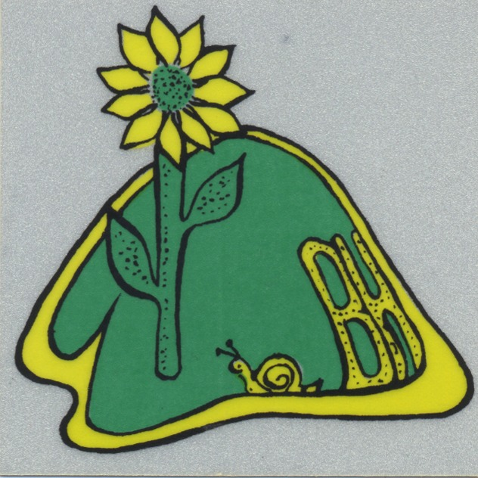

Welcome, new neighbors, to the community of Blair Hills.

Blair Hills is more than a name: it represents a vital piece of history of Culver City; it is a symbol of togetherness as neighbors have banded together to ward off actions detrimental to our quality of life; and finally, it is a community of people who respect each others’ lives and lifestyles, embrace each others’ families, and live together in a peaceful neighborhood.

Blair Hills has many faces: all ethnicities, cultures, religions. We celebrate our diversity, as we continue to learn from each others’ differences. You will find that the neighbors on your street and the Blair Hills Association welcome you.

The Blair Hills Association is the organized body that can represent your concerns to the city, and that also helps to plan some neighborhood activities. In the 1960s the association was formed, established dues and a leadership structure, which included executive officers and block captains, who help get the word out about meetings and do other localized activities.

The present officers are: Mary Ann Greene, president, Barbara Quave, secretary, Elizabeth Dixon treasurer, Bobbi Gold, membership chair and newsletter editor. All expenses are covered by the very low dues of $10 a year.

The Association has a website, www.blairhills.org and a newsletter. Included is information about city services, neighborhood activities, emergency preparedness, pictures, by-laws and announcements. The Association also holds meetings, helps with issues that impact the quality of life of the neighborhood (traffic, development, animals, beautification), welcomes and helps neighbors, offers decals for your cars, and prints a directory

In recent years, the association planned a diversity picnic, held a celebration attended by many of our local and state politicians, conducted neighborhood parties, and had a ribbon cutting ceremony following the completion of refurbishing Blair Hills Park in 2003.

We hope you will help by participating in the activities and the planning of them. We encourage you to help keep Blair Hills a clean, safe and welcoming place to live.

For all our Blair Hills neighbors
Please make sure your dog(s) respect our homes and lawns.
Do not allow your dog(s) to run loose in Blair Hills.
The city ordinance is included below for your reference.

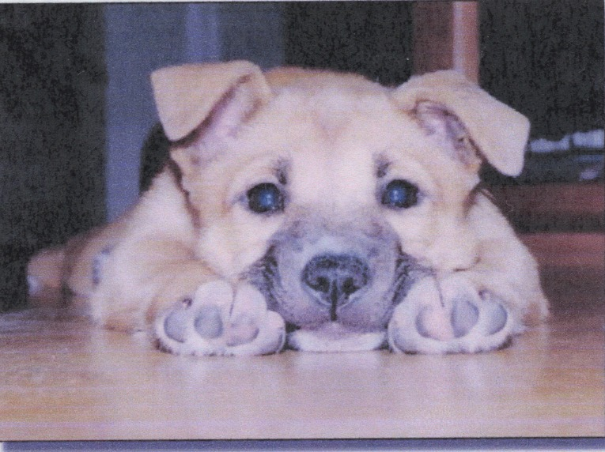

Culver City Ordinance, Title 10, Animals

10.32.010 Dogs -- Running at large prohibited -- Exceptions.
No person owning or having charge, care, custody or control of any dog shall cause, permit or allow the same to be or to run at large upon any highway, street, lane, alley, court or other public place, or upon any private property or premises other than those of the person owning or having charge, care, custody or control of such dog, in the unincorporated area of the county of Los Angeles, unless such dog be restrained by a substantial chain or leash not exceeding six feet in length and is in the charge, care, custody or control of a competent person. (Ord. 9454 § 1 (part), 1967: Ord. 8043 § 12 (part), 1961: Ord. 4729 Art. 7 § 701, 1946.)

10.40.060 Animal nuisances prohibited where.
A. A person having custody of any dog or animal shall not permit, either wilfully or through failure to exercise due care or control, any such dog or animal to commit any nuisance upon the sidewalk of any public highway; or upon the floor of any common hall in any apartment house, tenement house, hotel or other multiple dwelling; or upon any entranceway, stairway or wall immediately abutting on a public sidewalk; or upon the floor of any theater, shop, store, office building or other building used in common by the public; or upon the floor or stairway of any depot or station or public waiting room; or upon the floor, stairway, entranceway, office, lobby or patio used in common by the public; or, without the consent of the owner or person in lawful occupation thereof, any lawn, yard, or any other private property whatever, which is either improved or occupied.

B. It is unlawful for the owner or person having custody of any dog or other animal to permit, either willfully or through failure to exercise due care or control, any such dog or animal to commit any nuisance and to allow such nuisance to thereafter remain upon any public or private property not owned or possessed by the owner or person in control of said animal, provided that the person who owns, harbors, keeps or has charge or control of a dog (other than a sightless person who has charge or control of a guide dog) shall immediately and securely enclose all feces deposited by such dog in a bag, wrapper or other container and dispose of the same in a sanitary manner. Any person (other than a sightless person with a guide dog) who has charge or control of a dog in a location other than on the property of such person or the property of the owner of the dog, shall have in his or her possession a suitable wrapper, bag or container (other than articles of personal clothing) for the purpose of complying with the requirements of this section. Failure of such person to carry such wrapper, bag or container when in charge or control of a dog in a location other than on property of such person or the property of the owner of the dog or animal shall constitute a violation of this section.

C. For the purpose of this section a "nuisance" committed by a dog or animal shall mean defecation by said animal. (Ord. 85-0204 § 23, 1985: Ord. 9454 § 1 (part), 1967: Ord. 4729 Art. 9 § 904, 1946.)

Blair Hills

If you have any problems that the city hall, police, or other services could help address, please call the appropriate city office (Police and Fire Emergency 911, Police non-emergency 310-837-1221, City Hall – see below). Also, please let our Neighborhood Association know. Fill in a copy of this form and give to a block captain or officer of the Neighborhood Association.

Date: ______________

Your name: __________________________________

and contact information: ___________________________________________

_______________________________________________________________

What happened:

Who did you contact at the city and when did you contact them (any report you gave, person you talked to, their contact information, etc):

What action did they take:

What follow up action have you taken:

What further help do you need:
City Hall contact numbers:

ADMINISTRATION --- (310)253-6000
BUDGET & FINANCE/GRANTS ADMINISTRATION --- (310)253-6006
CITYBUS (Transportation Department) --- (310)253-6500
(310)253-6548 (TTY)*
City Garage (Equipment Maintenance Division) --- (310)253-6530/25
CITY ATTORNEY --- (310)253-5660
CITY CLERK --- (310)253-5851
(310)253-5851 (TTY)*
CITY TREASURER --- (310)253-5865
Revenue Administration (City Treasurer) --- (310)253-5870
Accounting (City Treasurer) --- (310)253-5850
CODE ENFORCEMENT --- (310)253-5940
COMMUNITY DEVELOPMENT --- (310)253-5700
Building Safety --- (310)253-5800
Housing --- (310)253-5780
Planning --- (310)253-5710
Redevelopment --- (310)253-5760
CREDIT UNION --- (310)253-6060
DISABILITY SERVICES: (310)253-6735 (TTY)*
FIRE DEPARTMENT --- (310)253-5900
Suppression --- (310)253-6805
Fire Garage --- (310)253-6840
Emergency Operations Center (EOC) --- (310)253-6850
Fire Prevention --- (310)253-5925
CERT --- (310) 253-5903
HUMAN SERVICES --- (310)253-6655
Recreation and Leisure Services --- (310)253-6650
(310)253-6659 (TTY)*
Environmental Management Div. --- (310)253-6470
Community and Social Services --- (310)253-6731
Senior Center --- (310)253-6700
Information Referral --- (310)253-6707
Nutrition Program --- (310)253-6740
Disability Services --- (310)253-6732
RSVP Program --- (310)253-6704
INFORMATION TECHNOLOGY --- (310)253-5950
PERSONNEL --- (310)253-5640
(310)253-5647 (TTY)*
POLICE DEPARTMENT --- (310)837-1221
Special Investigations Bureau --- (310)253-6102
Detective Bureau --- (310)253-6300
Operations Bureau --- (310)253-6200
Traffic Bureau --- (310)253-6250
POLICE/FIRE Non-Emergency: (310)837-1221
PUBLIC WORKS ADMIN. --- (310)253-5635
Engineering --- (310)253-5600
Maintenance Operations
(Facilities, Electrical, Street/Sewer, Tree) --- (310)253-6420
Sanitation
(Transfer Station/Street Sweeping) --- (310)253-6400
PURCHASING (Budget&Finance)--- (310)253-6550
SENIOR CENTER: (310)253-6736 (TTY)*
VETERANS' MEMORIAL BUILDING --- (310)253-6625
Ivy Substation --- (310)253-6640
"911" is still the emergency number to call for ALL calls - TTY* calls will be recognized and will be answered by another TTY*.
* : TTY stands for Speech- and Hearing-Impaired.

Ranger’s Office in Vista Pacifica overlook park:
558-4566 x104

History of Blair Hills

From Paul Patti, long time Culver City resident, via article in July 16, 2004 issue of The Front Page newspaper:

The area now known as Blair Hills was annexed by Culver City when Will Rogers Jr., owner of a ranch in the Blair Hills, was the district’s Congressman. The Rogers ranch was in the hills. Mr. Patti’s father, Ben, a stuntman and trick rider, and his brother, Carl, purchased the Rogers ranch in 1951. Ben and Carl Petti trained actors and actresses in how to ride, rope, and handle guns, bows and arrows for Western movies that were being made at the time.

Westerns were staples, both on television and in motion picture theaters. The actors Robert Taylor, Glenn Ford, Zsa Zsa Gabor, and Eleanor Parker were among the frequent visitors to the Petti Ranch. Among Carl Petti’s effects is a letter from Joan Crawford thanking him for his assistance on the climactic gun battle she fought with Mercedes McCambridge In the 1953 Nicholas Ray western, “Johnny Guitar.”

An extensive story in the Los Angeles Times in January 1952 told about one of the Petti horses being chased down Wrightcrest Drive, landing in an oil sump across the road for the Rogers’ house. The sump was a bottomless pit where oil, sand, and water were dumped from nearby exploratory wells. The newspaper account said it took five people and a tractor to pull the horse from the sump. Activism by Blair Hills neighbors in the early 1960s brought about Blair Hills Park, which is on the site of the old sump.

In 1953 Carl and Ben Petti worked almost exclusively with Will Rogers Jr. when he portrayed his father in the Warner Brothers bio-epic “The Will Rogers Story”. They worked with him again on a subsequent feature, “The Boy from Oklahoma”. Ben and Carl Petti sold the Blair Hills Ranch property in 1956. Ben died while the property was still in escrow. Carl and his wife moved to Hemet where he raised horses until his death in August of 2003.

From Lois Soter, and original resident of Blair Hills on Vicstone Court:

The majority of homes in Blair Hills were built by the Stone and Stone construction company. During their construction in the mid 1950s, the owner of the company named some of the streets: Vicstone, Stoneview, Blairstone [his granddaughter], Howardview [his son] and Lenawee [for his mother, Lena].

In 1955 twelve houses were built on Vicstone and three on Lenawee. Halloween weekend 15 families moved in with 29 children. Within a few weeks four more children were born (all girls). As there was a cement strike, no porches or sidewalks were put at that time. Only one family had a telephone, and that was because the father was a doctor. All others used a pay phone on the corner of Lenawee and Vicstone. This make-do situation continued until the cement strike was settled in early 1956.

Blair Hills Neighborhood of Culver City, A Short History
by Submitted by Mim Shapiro, 1999

Located in the Baldwin Hills, west of La Cienega Boulevard and south of Rodeo Road and Jefferson Blvd, this area was part of the Rancho de Los Bueyes Land Grant. The hillside was the home of old ranches said to have been populated by Will Rogers family, the Carl Pitti family, Charles Wright, and the Hetzler family.

Prior to WWII, some lots were carved out of the upper hill for home sites. When the war began, these lots were left as they were. In the early 1950's, a developer, Stone & Stone, purchased the lower area of the hill from La Cienega west and proceeded to develop plans for a community of single family homes.

They originally applied to Los Angeles for annexation. However, as luck would have it, Los Angeles had a moratorium on sewer connections at that time, so the builder applied to Culver City. The development was accepted and that’s how Blair Hills became part of Culver City, despite the fact that there were then no contiguous boundaries with the City itself. The project was started on what is now Vicstone Court, proceeded up the western side of Lenawee Avenue around to Wrightcrest as the main access street into the area from La Cienega Boulevard Two additional streets, then called Girthview (now Blairstone) and Stoneview Drive were constructed.

The development was a country, rural environment in the midst of a big city urban surrounding. We enjoyed the ambience of hiking in the hills, jack rabbits, snakes, birds, and other small critters. Most of the new homeowners were young families with babies and young children, much like a small town. As the development progressed, two apartment structures were built (on variances of R1A zoning). The City fathers at the time were not too particular about planning and these variances and the resulting problems of parking on narrow streets with no sidewalks created the need for dialogue between the City and the budding community. This became especially urgent when the builders asked to extend their apartments further up the hill along Stoneview Drive (at that time a 30 foot street).

At a neighborhood meeting, the residents voted to form a non-profit neighborhood association. Our attorney neighbors compiled a charter application to the State of California with signatures of 81 charter members. The charter was issued on Dec. 5, 1958. An name for the neighborhood, Blair Hills, was voted in, and Officers and a Board of Directors were elected. By-laws were prepared and the Blair Hills Association was ready for action.

Our stated purposes were outlined: to promote the general welfare of our community; to promote, advance, and to protect the interests of the property owners of Blair Hills and adjacent areas; to encourage and promote cooperation, fellowship, better relations and good will among the persons residing in Blair Hills and adjacent areas; to aid in the development of good government; to gather information and evaluate same, and to disseminate accurate information regarding proposed legislation, candidates, and administrative actions deemed conducive to the well-being of our neighborhood.

Various problems of traffic circulation from adjacent areas through the neighborhood and zoning issues were given immediate attention. The Association served as an entity to jointly discuss and communicate our needs to City Hall.

We proposed possible solutions to various problems and were well received by the Council and the Culver City Police Department in cooperative efforts to solve these problems to the mutual satisfaction of all of us.

Over time, many Blair Hills residents became active participants in Culver City as volunteers, appointees to various committee and commission posts, and elected officials on the City Council and the Culver City School Board. We have enjoyed an active electorate, maintaining a high average of voter participation (usually the highest of any Culver City precinct). We were very pleased to be a part of the Culver City Unified School District which was distinctly superior to other nearby districts.

Negotiations were begun with the School District for establishing a local elementary school because there were over 200 young children in Blair Hills, and the temporary solution of bussing youngsters was not acceptable for the long term. The negotiations terminated in the acquisition by the School District of the parcel of land upon which is the Linda Vista School. It was opened for business in September, 1959. The interim PTA chapter which was affiliated with Lynwood Howe (Then Culver) School, was spun off into the Linda Vista PTA. It became an active and productive part of the PTA system at both the Council and State levels.

Concurrently, the need for a neighborhood park was negotiated for with the Culver City Council. This led to the City acquiring several lots on Stoneview Drive which had been used as a dump, oil sump, and for other trash purposes over a long period of time. Through very consistent and diligent efforts, it was cleaned, graded, and a park was designed. This enabled the children and adults in the neighborhood to be part of the excellent Culver City Parks and Recreation programs. Play equipment was chosen and installed, a ball field marked, a basketball court built. An excellent coaching staff at the park enabled our youngsters to successfully participate in all aspects of city-wide sports activities. Lots of trophies lined the shelves in our homes.

With the Blair Hills Association and the PTA, and many community activities, we had a very close-knit community in our little corner of the city. We advanced our cultural and civic activities with community forums, meet the candidate nights, and annual July 4th Picnics and Games. We had two dinner-dances each year for the adults at nearby establishments. The close friendships and extended family ties developed through the years have continued for years, spreading to the next generation. A great reunion picnic brought over 500 people together in our Park.

Many families who are original owners or second owners of the homes are still residing here and enjoying the diversity of good neighbors living in friendship and neighborliness. Young families have moved into the neighborhood and the cycle continues.

